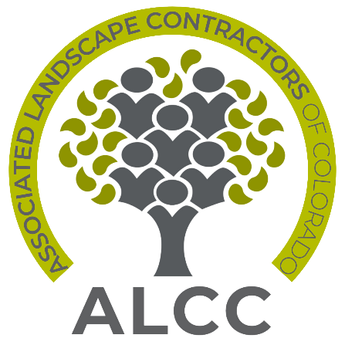

ALCC Volunteer Award Nomination Form
Nominations are due August 15 of each year

Bob Cannon Outstanding Achievement Award
The Bob Cannon Outstanding Achievement Award honors individuals who have given loyal, dedicated service to the landscape industry during his/her years of service, contributed ideas, programs and other endeavors to benefit other ALCC members and is recognized as someone who has improved the professional image of the landscape industry.

Name of individual being nominated:
Company:
Email address:

Name of individual/company nominating individual:
Company:
Email address:
Please outline in 3-4 sentences why you feel this person should receive ALCC’s Bob Cannon Outstanding Achievement Award:

John Garvey Person of the Year Award
The John Garvey award can be compared to ALCC’s “Person of the Year.” Named for John Garvey in a tribute to his work to get the certification test site ready in time for the 1997 CLT test, it’s presented to an individual who committed to an ALCC project and gave freely of his/her time and talent in the past year.

Name of individual being nominated:
Company:
Email address:

Name of individual/company nominating individual:
Company:
Email address:
Please outline in 3-4 sentences why you feel this person should receive ALCC’s John Garvey Person of the Year Award:
Outlook Award for Emerging Leaders
The Outlook Award represents the “up and comers” in the landscape industry and in ALCC. It acknowledges an individual who is newer to volunteer service with ALCC and has made a significant contribution to the industry and/or ALCC. The recipient must have some volunteer or leadership experience in ALCC, and also contribute significantly to his/her company. The Outlook recipient is thought to have a bright future in the industry and the association.

Name of individual being nominated:
Company:
Email address:

Name of individual/company nominating individual:
Company:
Email address:
Please outline in 3-4 sentences why you feel this person should receive ALCC’s Outlook Award for Emerging Leaders:

Stanley Brown Service Award
The Stan Brown award is given to an individual associate or affiliate member who has helped make the industry more professional, or promoted professionalism to the public and other industry stakeholders, has held a variety of volunteer positions in ALCC, is known for outstanding association service and the contribution of ideas, programs, and/or educational endeavors that have benefited other members of ALCC and who has been a loyal supporter of ALCC and Colorado’s landscape industry in general.

Name of individual being nominated:
Company:
Email address:

Name of individual/company nominating individual:
Company:
Email address:
Please outline in 3-4 sentences why you feel this person should receive ALCC’s Stanley Brown Service Award:

ALCC Woman of the Year Award
The Woman Leader of the Year Award recognizes a distinguished female ALCC member who embodies an exemplary spirit, proactive leadership, and profound dedication to the landscape and lawn care sector. This award serves to spotlight individuals who inspire their peers and serve as role models for women across the industry. To be eligible for consideration, nominees must meet the following criteria:
1. Active membership in the Associated Landscape Contractors of Colorado.
2. Holds a leadership position within a landscape or lawn care firm.
3. Recognized as a source of inspiration and motivation for other women in the industry.
4. Demonstrates remarkable contributions to the industry through leadership and active
involvement in community service.

Name of individual being nominated:
Company:
Email address:

Name of individual/company nominating individual:
Company:
Email address:
Please outline in 3-4 sentences why you feel this person should receive ALCC’s Women of the Year Award:
Nominee's Positions within ALCC and Affiliated Organizations: (List all relevant positions held by
the nominee within ALCC and affiliated organizations)
Inspiration to Women in the Industry: (Explain how the nominee serves as an inspiration to
women currently in the industry or pursuing a career in it)
Nomination requires a minimum of two (2) letters of recommendation excluding nominee’s current employer, such as a client or vendor, who is not related to the nominee or from the ALCC Board of Directors or staff.

